Report four: findings from interviews with staff at Bradford District Care NHS Foundation Trust

Our evaluation findings are presented in five linked reports, to be read as a set or standalone.

Matthew Riley, Involvement Partner, Bradford District NHS Foundation Trust

Jacqui Hooley, Principal Social Worker, Bradford District NHS Foundation Trust
Hisham Almahayni, Senior Service Manager, Bradford District and Craven Mind
Mehnaz Akhtar, Service Manager, Bradford District and Craven Mind

Acknowledgements
We would like to thank and show our appreciation to the personal health budget (PHB) approval and evaluation team, the social worker development team, our involvement partners with lived experience, our ward staff who have supported applicants to apply, our leadership teams across mental health services, our senior leadership team and to Collete Turner who helped apply for the pilot funding initially.

Contents
Key evaluation findings 3
Introduction and scene setting 4
Our evaluation approach 8
What we did 10
What we found: 12
What worked well? 12
Impact of personal health budgets 20

Key evaluation findings

Staff from Bradford District Care NHS Foundation Trust
- Staff from the approval and evaluation team reflected and highlighted how reviewing applications helped remind them of the personal recovery journeys patients take.
- Staff supporting our Trauma Informed Personalities Pathway (TIPP) said how the personal health budget (PHB) allowed different ways of seeking support and helped build trust as it delivered something which had been offered to the patient.
- Our community rehabilitation team said that support offered in starting their community journey, otherwise they would have remained in hospital for longer potentially disrupting or delaying their care and recovery journey.
- Inpatient staff valued the support in building therapeutic relationships and thinking creatively and differently in supporting social needs as part of their inpatient journey.
- Staff found our community mental health services identified how it had empowered patients to be involved within their own recovery and had boosted engagement not only within their service but wider community support also.

Introduction and scene setting
The purpose of one-off mental health PHB’s is to give people a greater degree of choice and flexibility in managing their mental health in the context of their daily life.
They offer the chance to tailor support to specific stressors, interests or aspirations, as identified by the person themselves and can be personalised for ethnic, cultural, or religious preferences.
PHBs are focussed on meeting identified health needs and can be spent on almost anything that provides an individual with appropriate care and support.
Bradford District and Craven have areas with high levels of multiple deprivation and a high prevalence of severe mental ill health.
We know from the work carried out by the Reducing Inequalities in Communities programme that if you travel 10 miles from Wharfedale to Manningham, healthy life expectancy drops by over 20 years.
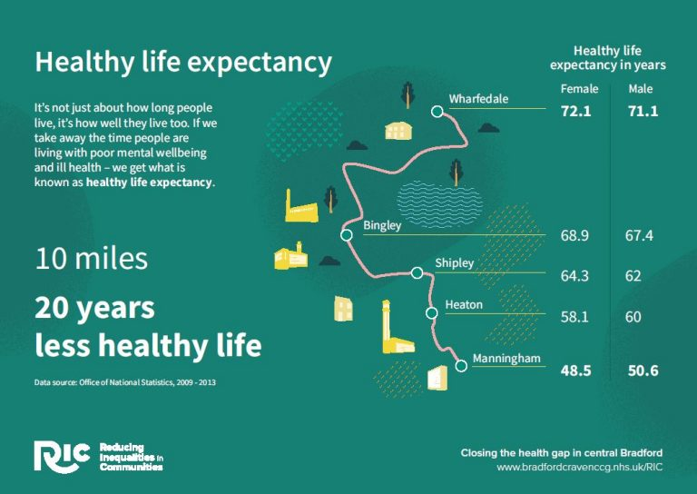
We are currently within phase one of our pilot roll out, we began with an initial focus on our inpatient wards including out of area placements and our low secure beds, as well as our Trauma Informed Personality Pathway (TIPP) service.
Data shows us that those with Severe Mental Illness (SMI), Neurodiverse or are from an ethnic minority have poorer health outcomes, these include longer stays in hospital, increased chance of reattendance to hospital, poorer access to community support and reduced access to preventative support.
We did not place restrictions on who from these populations could have access to a PHB other than being over 18 years old. Initially we had it at working age adults and not those in our older people’s service (over 65).
However, as part of the Community Mental Health Transformation (CMHT) programme we removed the upper age barrier to include older people.
We then additionally included access for those children and young people who would be accessing an inpatient bed, while as a Trust we are not commissioned to provide inpatient care to Child and Adolescent Mental Health Services (CAMHS) we had a significant pressure for inpatient beds for our children and young people, as a voice within the Bradford District and Craven Health and Care Partnership we applied a Reducing Inequalities lens and identified it would be just and equitable to include anyone who resides in Bradford District or Craven and were in an inpatient bed due to their mental health deteriorating.
We additionally recognised that we had many people accessing support across our services which was like that of our TIPP service however were not under their direct care, we therefore expanded to consider those who were under multi-agency care plans where it would aid in the prevention of admission.
Following our evaluation we have agreed to adjust our working to cover those who have a multiagency care plan (3 or more services) where it is identified the individual is at risk of deterioration and/or admission into hospital this is to reduce inequalities and provide equity of access to the communities of Bradford District and Craven.
To be eligible for a PHB there is no need to be formally sectioned or being eligible for section 117 (S117) aftercare under the Mental Health Act (MHA). Those with eligible S117 aftercare have access to more formal Personal Health Budgets since December 2019.
Additionally, we did not start off with any set funding amounts, but we did have one funding system across the patch which is being managed by our system partner Bradford District and Craven Mind.
Within the first few months we recommended a soft limit amount of £300.00 to ensure equity and sustainability within the approach, while we would allow higher ones these would be reviewed to see if a PHB was the most suitable way to support that person’s recovery journey.
Our evaluation findings are presented within this report (four other reports form the overall evaluation. These can be read as standalone or as a complete set.)
Report one: Evaluation - Key findings.
Report two: Overview summary of findings from personal health budget holders, staff and system partners highlighting key findings and learning.
Report three: Findings from interviews with patients and carers.

Report four: Findings from interviews with staff.

Report five: Findings from delivery partner and system partners.

Our evaluation approach
The primary focus was the experience of staff working across Bradford District Care NHS Foundation Trust who worked with people who had accessed or applied for a PHB.
We wanted to review the experience of staff on the implementation of PHB’s and the delivery of the pathway.
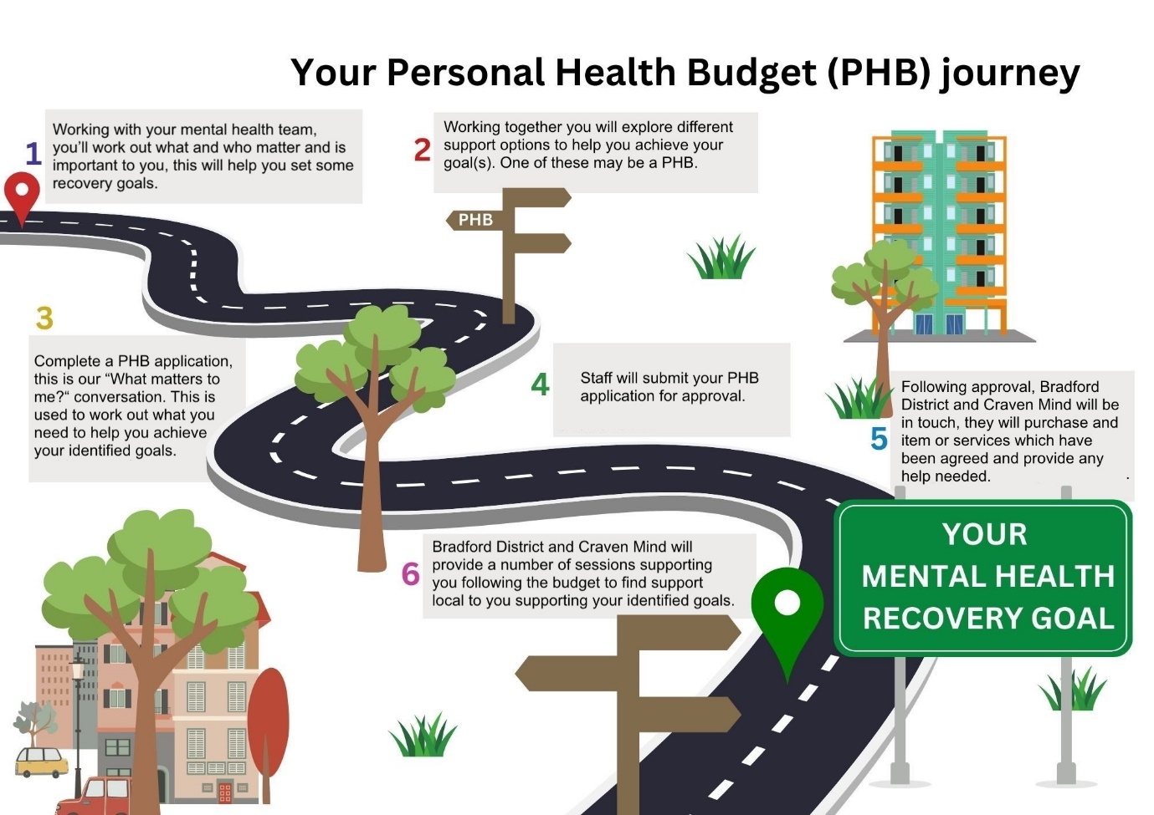
Inspired by East London NHS Foundation Trust
We invited staff from our inpatient ward teams (including ward managers, occupational therapists, health care assistants, ward nurses), our community mental health teams (community mental health nurses, social workers, support workers), our community rehabilitation team (occupational therapists), our approval and evaluation team (this is a combination of staff from different roles, teams and services) to provide their reflections and feedback around their experiences of the PHB pathway.

What we did

A member of staff from Bradford District Care NHS Foundation Trust and an involvement partner (person with lived/living experience) contacted different members of staff inviting them to have a reflection on their experiences and feedback to them.
The interviews/feedback collection was semi structured and covered the individuals experience and journey from their own experiences of supporting individuals apply for PHB’s until their involvement or knowledge of the process ended.
As each application is personalised some would have been fully delivered whilst the patient was in hospital so some staff will have supported the individual through the entire pathway.

What we found:
The PHB process
Staff told us that the application process was easy, that the evaluation and approval team provided quick responses and that the support offered by our delivery partner Bradford District and Craven Mind was good. They said, “Really easy application process, quick response times and good support offered by MIND.” Other staff highlighted the support of the approval and evaluation team in supporting other avenues of support and helping other things to be considered, they said “The team have been efficient in their responses and been willing to support in a variety of ways.”
Staff also told us that it allowed them to provide support to patients in a different way and offer alternative support which they would not be able to provide generally. They said, “We have been able to support patients to engage in occupations of interest that we normally would not be able to facilitate.”
Finding out about PHB’s
Our inpatient staff told us how “Personal Health Budgets were introduced to Ashbrook by Matthew and Jacqui visiting the wards. They came at a time where there was an obvious gap in the support which we were able to offer service users in terms of financial support.” When the pilot launched, people with lived experience and staff supported the wards knowledge of PHB’s by delivering sessions in person on the wards and virtually to ensure as many ward staff knew about the process as possible, they produced posters aimed both at staff and patients to support understanding of what a PHB could be used for and their associated benefits.
Reflections from our inpatient staff help evidence how PHB’s managed to bridge a gap between support available traditionally and how it allowed ward staff to provide additional support in a creative and person-centred way.
Our ward staff explained how since finding out about PHB’s they have been promoting PHB’s in several ways “On the ward, we are doing the following to promote PHB’s. We have 2 allocated PHB champions, who are occupational therapy staff, we have a notice board dedicated to PHB with information displayed, we have included an information leaflet about PHB in admission packs and spreading awareness to staff with a segment in the monthly managerial briefing around how and why these are used.” By our inpatient staff taking these positive steps it helps embed the knowledge not only on this ward but across all our inpatient wards, it supports the sustainability of the project as staff will know about the opportunities available from a PHB and the ongoing approaches being used to ensure both staff and patients are continually informed about their right to have access to a PHB.
Purpose of PHB’s
Our pilot of one-off personal health budgets in mental health has been focused on supporting personalised and individualised recovery journeys for those with severe mental illness and/or reducing barriers preventing them to access suitable care in the community.
A key focus was looking at how we could provide care differently and provide wider support from system partners to help someone leave hospital or preventing an admission.
This has supported people to feel confident and supported them to be able to leave hospital earlier, this is because we have removed barriers or have been able to provide alternative and additional support to enhance their access to community support.
Staff highlighted how a combination of the items provided by the PHB, the signposting and referrals for additional support had been beneficial in supporting patients to receive care in their local communities. They said “The community rehabilitation team are extremely grateful for the support, resources, and guidance of this pilot. Without this it would have been extremely difficult to achieve these smooth transitions for service users.” Staff explained that how without the support of the PHB that some of these patients would have been unable to move into properties within the community, or they may have moved but been unable to have access to basic necessities which would have likely caused their mental wellbeing to deteriorate and likely result in them returning to hospital.
Staff also highlighted that without access to PHB’s that patients may have been delayed in hospital whilst other support was located, this could be support from the local authority, awaiting agreed funding from statutory services such as care act funding, section 117 funding, access to continuing healthcare or other health and social care funding. Staff said how “Without the proactive timely approach this would have resulted in further delays.” Staff identified how this likely would have impacted negatively on the patient’s mental wellbeing and recovery as well as preventing someone else from accessing a hospital bed.
Engaging with PHB’s
As a key part of working towards the NHS long term plan of personalised care, we felt that our one-off personal health budgets for mental health were able to be a key driver in beginning to deliver this locally.
Data tells us that a lack of personalised care which fails to recognise or meet people’s needs (such as generic care plans) and the culture of care (including a lack of dignity and/or respect for patients or behaving in a way which is uncaring, abusive or discriminatory) causes poorer therapeutic relationships within inpatient services, decrease trust in community and inpatient services, increased length of stay in inpatient services and accessing care at a later stage often at an increased acuity.
Personal health budgets offer the opportunity to provide care in a different way, by including and working with the patient directly to consider what support and care looks like to them to aid their own recovery journey.
Our “What matters to me?” based application form allows a conversation between staff and the individual to look at what and who is important to them, allowing everyone involved in the process to reflect and consider alternative approaches to delivering care in the future.
This allows our approval and evaluation team to review the information recorded and find appropriate support within the wider community to provide wraparound support when they leave hospital.
This process allows more control and choice within a person’s own recovery, it provides an opportunity for services to provide care can be provided differently and help to foster better relationships between patients and health/social care staff. This enables better opportunities for engagement within the health and social care sector, and the wider community support offers also.
Staff said, “In a climate where there are varying financial pressures the personal health budget has really aided service users to ease their worries and think collaboratively around how their discharge can be made smoother.” By working together staff have been able to engage more consistently with patients, reduce their concerns and provide reassurance about accessing care differently in the community.
PHB’s have provided the opportunity to provide culturally appropriate, recovery focused care in a way which engages and includes the individual.
We have been able to provide care differently and supportive of wider health and social care frameworks such as the Bradford District Multi-Agency Hoarding Framework, where the PHB has allowed us to follow the guidance in the framework but provide the intervention differently and involving the person so that it improves outcomes and engages all parties involved.
Choice and control of PHB’s
Part of the NHS long term plan around PHB’s is that they enable and support a level of choice and control over a person’s own care and recovery. Whilst our PHB’s have been more structured and restricted in delivery than wider PHB’s which support packages of care, they have allowed personalisation to elements of their own care provision by providing choice on who or what has been provided.
Staff told us how “They have supported service users to consider what is important to them and how this may possibly aid their recovery and rehabilitation.” The process of empowering patients to be involved in the delivery of aspects of their own care and recovery has allowed them to focus holistically on their overall wellbeing and recovery. It allows a conversation to be had around what aspects of their life are important to them and where they want support in improving those areas of their life which are important to them.
Flexibility and ongoing support
Our delivery partner Bradford District and Mind Craven assign a PHB practitioner to each application when it is sent to them. This practitioner provides interventions which support purchasing the identified support but also provide signposting and support referrals to other services. Whilst most of these are to services provided by Bradford District and Craven Mind they also signpost to other services when and where appropriate.
Additionally, our approval and authorisation panel identify and support signposting and referrals to other sources of support when they evaluate an application form, this could be of other places to provide some of the items, it could be for complimentary support for the support requested or it could be based on other information provided by the applicant within their application.
When we spoke to staff, they told us how “Matthew, Jacqui and Sameena have been accommodating and extremely supportive. They have used their skills to think creatively around how the budget can be best used and educated the team to consider other sources to support service users going forward.” By acting as one, working together as a system and pooling our shared resources we have been able to provide extra support to patient, and also to staff within our inpatient and community services.
This has allowed community services to wrap around the patient in the community and provide support to them, their support network but also supporting staff across different services, often working together in partnership to provide support where the patient feels safe, at a time convenient for them.
Staff also provided feedback around how “At times they have gone above and beyond to support the smooth transition of service users moving into Hollingwood Lane. This even extends to offering to build furniture and changing of locks.” Part of working as a system has allowed support to be tailored to the patient, it offers the opportunity for a wider workforce to support the person ensuring that appropriate support can be provided at the right time.
By including people with living/lived experience of accessing mental health support it has supported different conversations between staff and patients, allowing discussions to be had around who can provide support and when, allowing the patient a level of choice and control around who provides support whilst staff have been able to support joint visits with other services or organisations allowing greater flexibility in the delivery of their care.
PHB’s have supported services to understand the intersectionality between a person’s mental health and their wider identity. This has allowed people to access support from organisations they have not previously been able to access. It has reduced barriers to earlier interventions of support for the individual and supports their ongoing engagement with their own recovery.

Impact of personal health budgets
We asked staff to reflect on their experiences of PHB’s since the pilot began, this could have been through the lens of their own experience, the experience of staff, the experience of patients or a combination of these.
Staff told us how the “PHB has been an amazing resource for so many of our patients and has supported the smooth discharge and transition from hospital to home.” The PHB pilot has given the opportunity for care to be delivered slightly differently to how it has been done traditionally. Whilst the provision of the identified item/service is a new concept the wider signposting and community resources were already readily available within the community.
By having a “What matters to me?” conversation with the patient whilst they have been in hospital it has allowed support to be identified, referrals submitted, and support agreed to support them as they leave hospital. This provides support, safety and reassurance to the patient before they leave hospital. This has helped to empower patients to leave hospital and have a different perspective to their recovery compared to previous experiences.
Staff also highlighted how “The personal health budget pilot has been a pinnacle aspect for the community rehabilitation team. It has allowed the team to support service users’ recovery goals and facilitate early discharges into Hollingwood Lane.” We have supported patients with a PHB who historically have had long stays in hospital, challenges living alone or issues managing a tenancy. By providing a PHB we have been able to help them create a home environment which works for them and supported staff across the project with additional signposting and raising awareness of other support available to continue their recovery.
Staff highlighted how “It’s working so well and making such a difference.” The pilot has supported staff to have different recovery focused discussions with patients whilst in hospital, it has helped prepare discharge plans with a focus on recovery as they leave hospital and continue to access care and support within the community.

Reflections from our inpatient staff told us how “Personal health budgets have been invaluable in offering not only financial support but in building rapport and therapeutic relationships with our service users, by allowing them to feel validated and listened to.” This reflection identifies how a PHB provides more support than just a product or service. It can be used as a tool to facilitate meaningful change in a patients journey and experience of care provision. It also supports staff in building rapport and therapeutic relationships, data shows us when patients feel listened to, this helps improve safety on the ward, this helps reduce incidents on the ward and improves the culture and experience on the ward, benefitting the wider ward community of patients and staff.
Other feedback
Staff who have been supporting the process from inception advised how initially it was very time consuming particularly around educating and supporting staff around PHB’s.
They also highlighted that a large amount of time was initially spent on recording data and reviewing information before sending the application over to the delivery partner Bradford District and Craven Mind. They explained that this was the first time they are aware of a project like this being implemented locally, but support from other stakeholders and from system partners had simplified this process as it has developed.
Staff explained that another challenge had been around time taken to collect feedback following the PHB. Challenges around when to collect feedback, how to collect feedback and peoples understanding and interpretation of questions being asked caused delays and inefficiencies within the process. A review is currently taking place looking at alternative methods of feedback collection in future.
Staff said they felt very proud to be a member of the approval and evaluation team, it helped improve their understanding of community resources available locally and other ways of being able to support their patient’s recoveries.
They also identified that being able to witness patient’s being involved in planning their own recovery journeys was very positive and showed true co-production and different ways of working were possible.
Community staff identified how having the application process accessible on their mobile phone through an application would assist them in being able to have service users apply for a PHB.

Conclusion
From discussions with staff across Bradford District Care NHS Foundation Trust we build a picture of the impact PHB’s have had on our workforce, on our inpatient environment, on our community staff and on the patients themselves.
It allowed a space for staff to take a moment and reflect on how their practices had changed and what the impact of this had been.
Multiple staff identified improvements in working relationships between different professionals, improvements in therapeutic engagement between staff and patients.
Staff were enthusiastic about PHB’s and having them as a useful tool to help people return to their home and local communities. By providing care closer to home in a way which has been identified by the patient it allows new dynamics to be created supporting sustainable recovery pathways and empowering choice.
Staff reflected how the wider support offered in addition to the PHB had improved their knowledge of services, it improved their understanding of referral criteria and processes, and it had helped support people to access support earlier and differently to how they had done previously.
Staff also mentioned how it had improved partnership working between different organisations and across the system, not only with the Voluntary, Community and Social Enterprise (VCSE) sector but also with other statutory provision such as the local authority Bradford Council. It did however also highlight some difficulties in equity for some of our patients who reside in North Yorkshire where different processes were in place, but staff did identify that it had facilitated new discussions to occur across the system.

